Prep Meeting 34

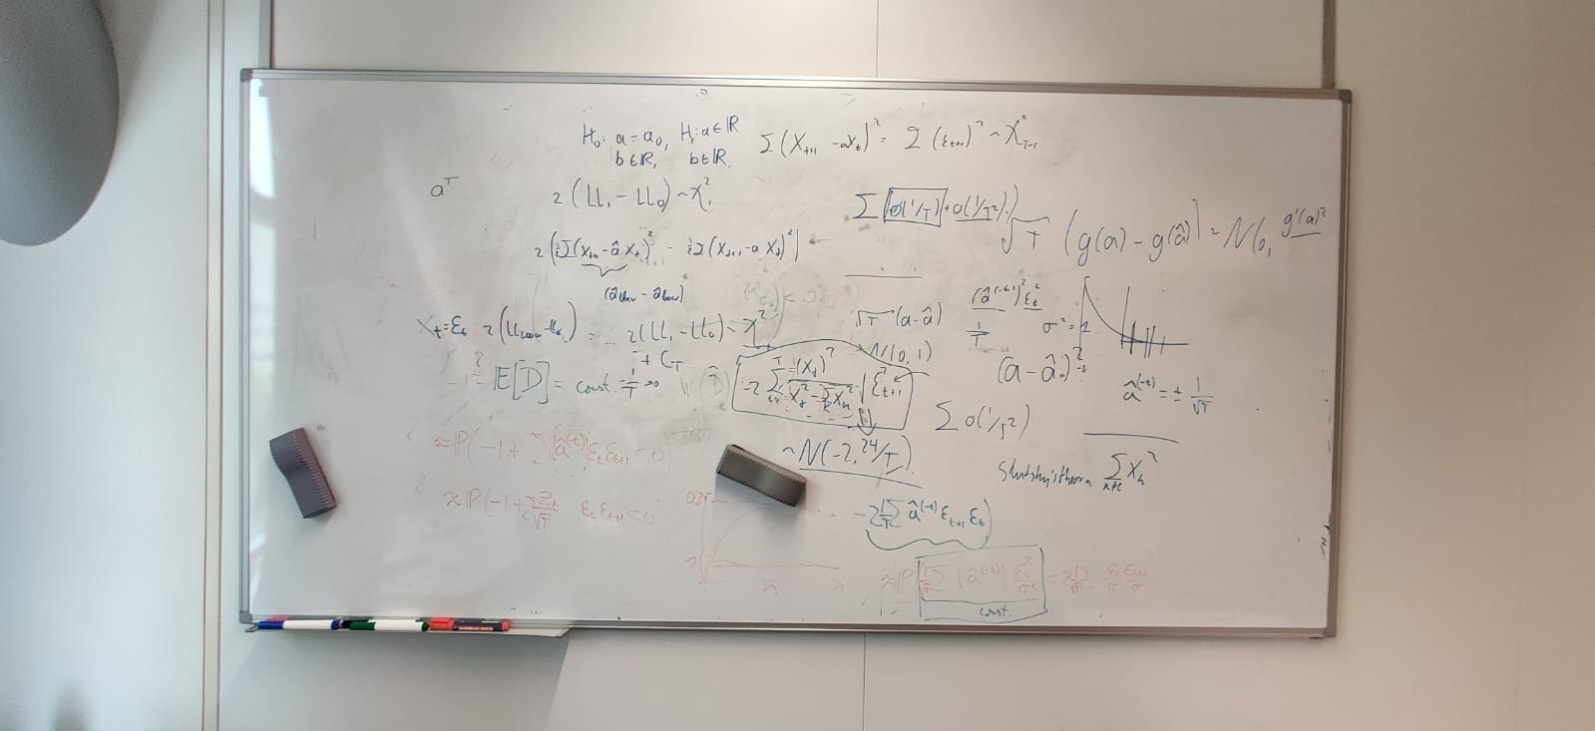

Derivations were nice and interesting according to Rui.

Use Slutsky’s Theorem to get the bottom out of it, should be constant. Then, the rest should get this -2, and the covariance should be -24 / T.

Check Mean Squared Error comparison on new data when using the both model types.

Try other noise with zero-mean, do we still have shifted chi-squared, and what is the shift?

Sent report, hopefully good feedback.

Investigate twitter data, real-life data should be good.

# Assessment Committee

Mailed around, asked some friends, and had the following clarification:

“The assessment committee referred to in section 1 consists of at least three voting members, one of whom is the graduation supervisor. The voting members together determine the final mark for the master project. The members of the Assessment Committee are appointed as examiners by the Examination Committee according to article 7.12, section 3 of the Higher Education and Research Act.”

“At least two of the voting members are an assistant professor, associate professor or full professor within the Department of Mathematics and Computer Science according the division outlined in article 4.2 and are independent from each other, understood as belonging to a different cluster.”

“So, hypothetically, I am doing a double degree project in IAM and CSE (track in DSiE). I have one graduation supervisor from Statistics. We invite another assistant professor from the Operations Research cluster within IAM and another Postdoc from Statistics. This would satisfy all requirements as I have read them in the .pdf, correct?”

“Yes you have interpreted this correctly!”

Conclusion: Even “just” the assessment committee consisting of Rui, Jacques, and Alex would suffice.

# Using Different Noise

Now using **Laplace noise**, with parameter *mu* *= 0* to get zero-mean noise, and parameter *lambda / b* = ½ sqrt(2) such that the variance is 2b^2 = 1. We first investigate the probability of correct acceptance. It seems not to differ significantly, also converging to the same value.

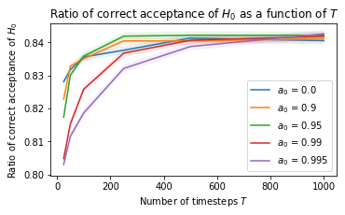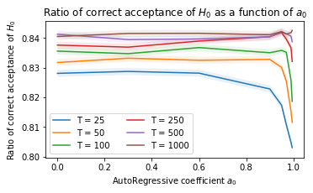

**Laplace noise with unit variance: Seems same as normal noise.**

Let us first investigate LL_0 – LL_1. Previously, this had a chi squared distribution with one degree of freedom. Now, let us consider the *Laplace noise* version for *a = 0.0, T = N = 10,000 (left)*. Furthermore, let us also consider *a = 0.9, T = N = 10,000 (right)*.

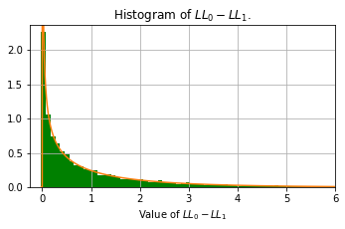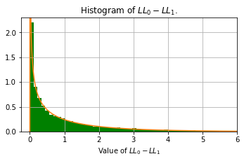

We see that the chi-squared-ness of LL_0 – LL_1 still holds, so Wilk’s theorem still applies.

Now, let us consider the value for *CT* and its approximate value for *CT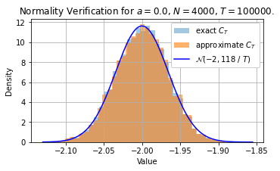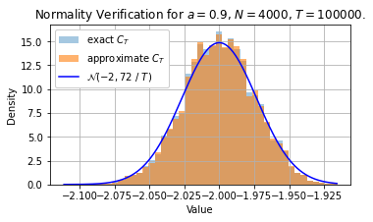*

We see that the mean of -2 still applies. However, the variance differs slightly. It is slightly wider, but the variance still converges to zero as T tends to infinity. For *a* larger, we still see that this is still the case, and even the constant seems to be slightly smaller. Nevertheless, the main result still applies, as we see in the figures below (*left: a = 0.0*, *right*: *a = 0.9*) for *T = N = 10,000*.

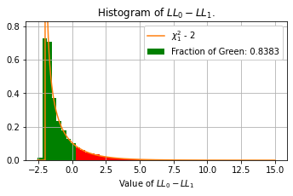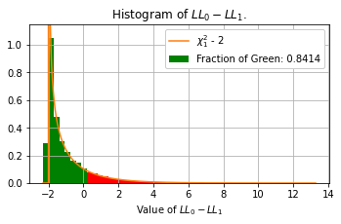

**In conclusion: It seems that different noise values do not change the scenario here, at least for when E[epsilon] = 0, E[epsilon^2] = 1.**

**Laplace noise with variance of two: Rescaling required.**

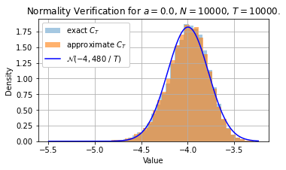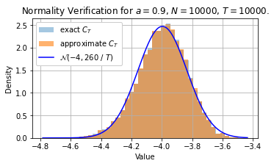

The mean has now doubled, and the variance has approximately quadrupled, as expected.

Interestingly, the LL_0 – LL_1 is now no longer chisquared. It seems as if there is not enough density on [0, 2], and too much density on [2, 6]. This applies for both *a = 0.0 (left)* and *a = 0.9* *(right)*.

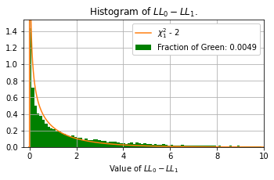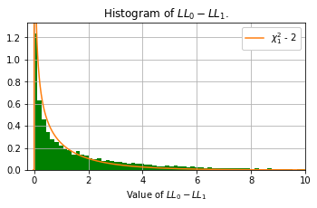

Now the shifted plots are not that different, again too much weight on [-2, …], and not enough weight on [-4, 2]. Perhaps we need more samples than 10,000? Did also *50,000*, but that did not change anything.

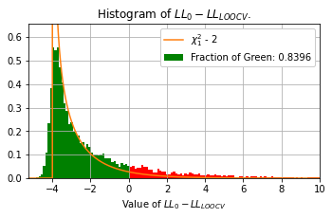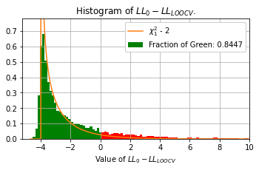

Interestingly, changing the Laplace parameter also affects the chi-squaredness of the distribution of LL_0 – LL_1. Interestingly, the fraction of green remains approximately 0.84 though.

**Laplace noise with variance 2: Rescaling.**

Interestingly, if we rescale, we **do** get the chi-squared distribution. If we zero-mean and unit variance the LL_0 – LL_1, we get a nice chi-squared distribution. Let us now consider a value for *b* such that the covariance is equal to 2, so b = (0.5 s)^(1/2).

The value for C_T will approximately have mean -2 * s = -4.

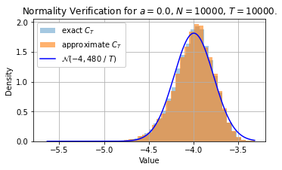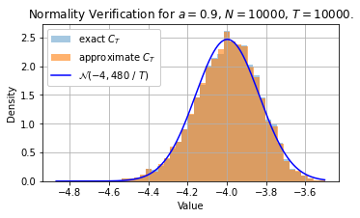

*a = 0.0 a = 0.9*

*Standardizing LL_0 – LL_1: (LL_0 – LL_1) / s*

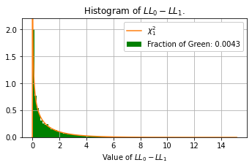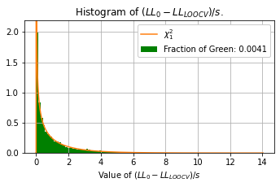

*a = 0.0 a = 0.9*

*Standardizing LL_0 – LL_{LOOCV}:* ((LL_0 – LL_{LOOCV}) – 2 * s) / s)

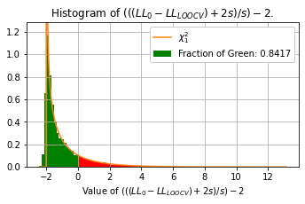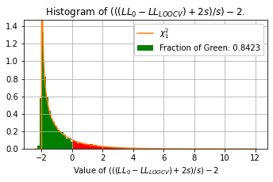

*a = 0.0 a = 0.9*

Interestingly enough, the probability is still 0.84.

**Change Normal distribution with variance of 2. Get same problem? Again, same solution.**

Let us now consider normal noise with a variance of 2, do we again need rescaling? Seems like we do, which is rather strange really.

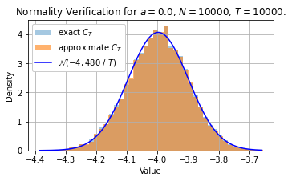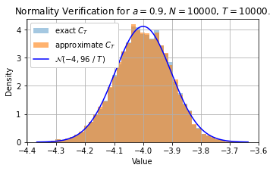

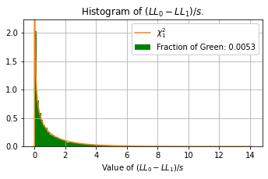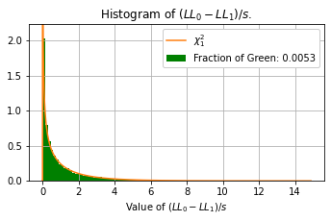

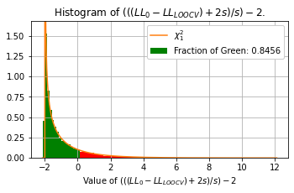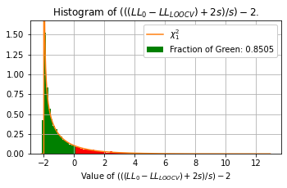

**Conclusion: For unit variance, nothing changes really. However, when the noise variance is no longer unitary, we need to rescale the log-likelihoods to get the chi squared distribution shape. Interestingly, this does not affect the probability of success, as the zero point does not change.**

**However, it seems strange that for e.g. the normal distribution, this rescaling needs to be done; would Wilk’s theorem not have that this is chi squared distributed already? Why is this rescaling needed?**

# Further Derivation using Slutsky’s Theorem

Put the 1 / (Xt^2 – sum X_k^2) out of it, and sort of treat it as a constant. We have case 3:

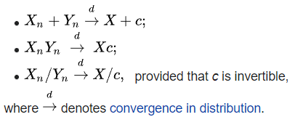

**Slutsky v1**. Let us rewrite our approximate *CT* as

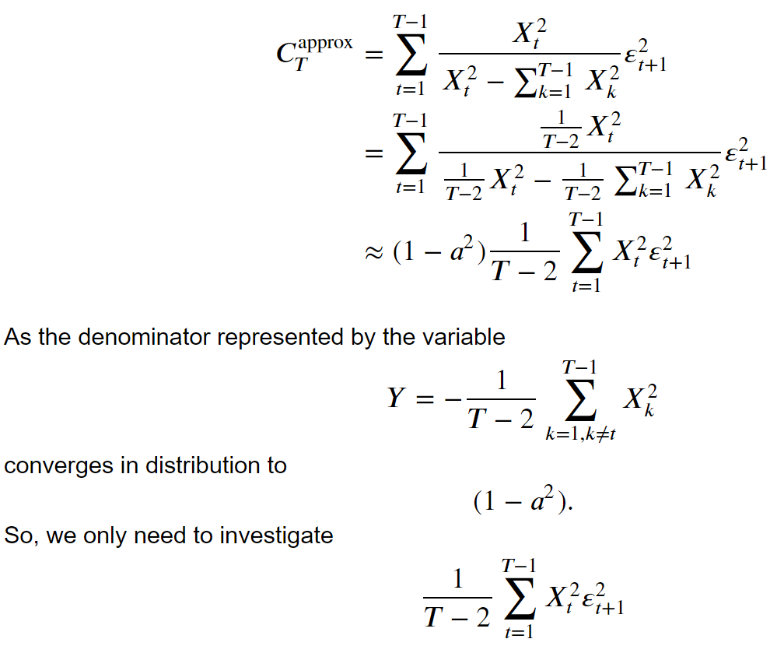.

**Slutsky v2**

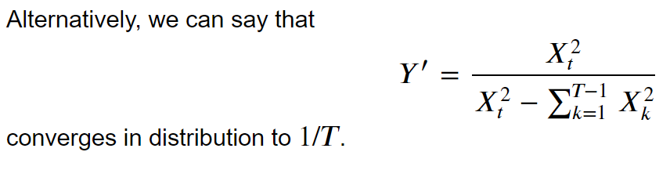

Slutsky’s v2 then corresponds to a sum of i.i.d. scaled random normal variables with mean V(epsilon).

Low, let is compare Slutsky’s to our covariance:

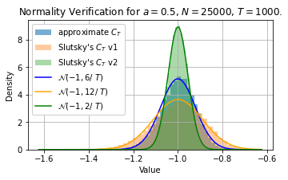

They are not the same, because for T tending to infinity, both converge to a point with mean -1 and covariance 0. Interestingly, Slutsky’s v1 is **wider** than the approximate C_T, by a factor of 2 approximately. However, Slutsky’s v2 is **narrower** than the approximate C_T, by a factor of 3 interestingly. Nevertheless, all have the same mean.

Also, for different values of the noise component, slutsky’s remains adequate, although there is a difference in covariance again. Here, we used **s = 2**, so that the variance of epsilon now is s^2 = 4, rather than 1^2 = 1.

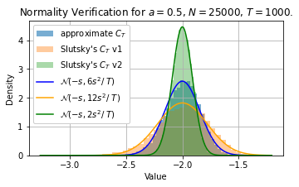

# Smaller probability of success when *a close to 1, is it problematic?*

We saw that the probability of success was slightly lower when a was close to 1. However, Rui mentioned that this might not be problematic.

**Setting:**

We generate X using an AR(1) model with coefficient *a* for *T* timesteps. We compute a-t. Now, we generate X2 the same as X. We compare the score of using *a* to the average score of using *a-t*. We try this for varying values of *a* and *T*, and try each pair (*a, T*) 1,000 times and compare their means with accompanying standard errors.

**Varying values of *a* as a value of *T* on *X2.***

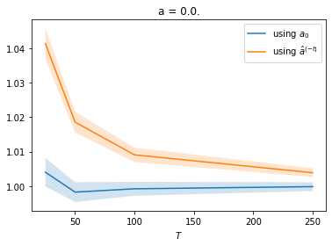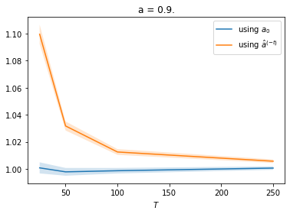

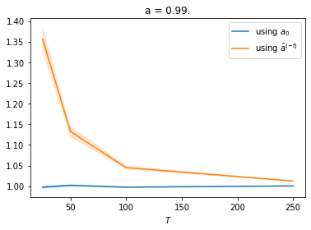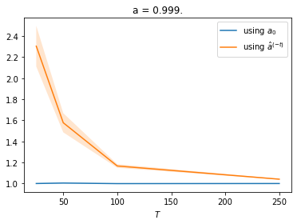

We see that all the time, using *a0* is by far the better option. Furthermore, this difference is greater when *T* is small, and when *a* is closer to one. If *T* is smaller / *a* is closer to one, then the difference between using the LOOCV estimate and the original *a* increases quite sharply. If we consider this for varying values of *T*, this is also the case. We see a huge increase as *a* gets closer to one.

**Varying values of *T* as a function of *a* on *X2*.**

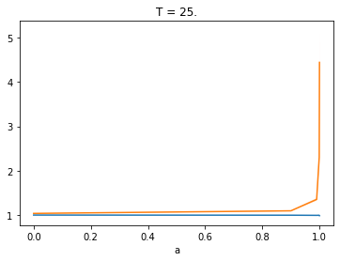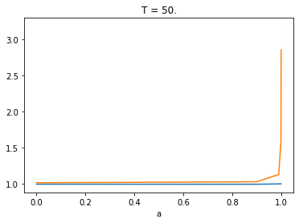

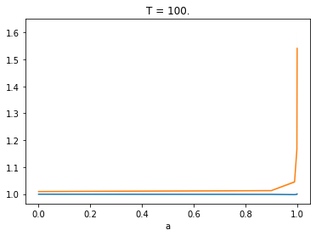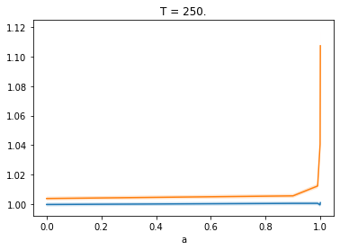

So, the problem seems to be even more dramatic for larger *a* and for smaller *T*. Now, let us consider the error on the original data. We now expect the LOOCV estimate to be better, as it “overfits” on the data.

**Varying values of *a* as a function of *T* on *X1*.**

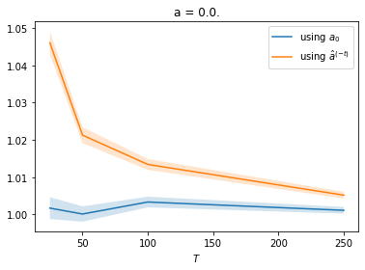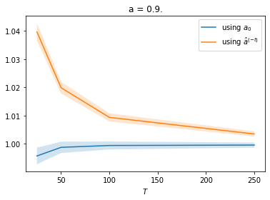

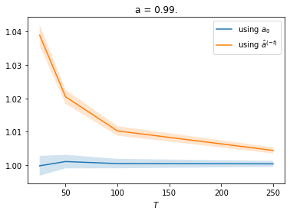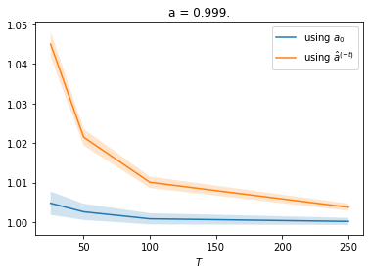

**Varying values of *T* as a function of *a* on *X1*.**

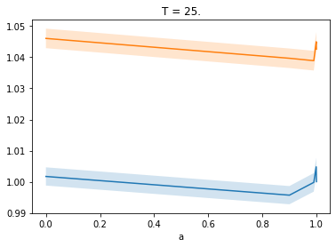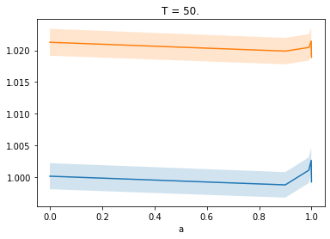

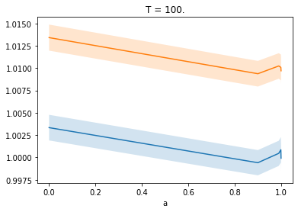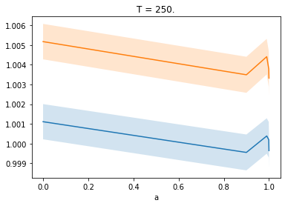

We can also increase the length of X2, say 10 * T rather than T. This only increases the discrepancy between the two. We can also use the expected value, so for T2 -> infinity, which again only increases the discrepancy even further.

# Writing

Continued quite a bit on the writing, many thanks for the feedback. First version of Introduction is done now, incorporated all your feedback.

At the moment, working on improving Chapter 2 to make it less dry. Also have some things in minds for the previous work section, but remains to be seen how extensive each part should be, e.g. write out algorithms all that explicitly, etc.

# FMRI Dataset

Recovered and downloaded the FMRI dataset of the Survey that Alex send. Note that it is simulated data, not real-life data, yet they claim it is realistic. However, they also state that “lag-based approaches perform very poorly.”

Example of one of the 28 time series:

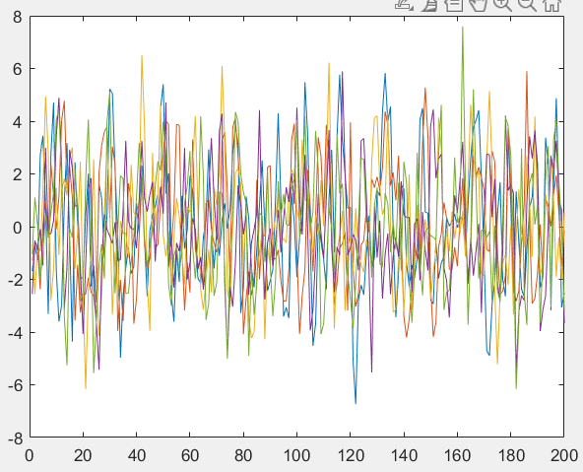

# Twitter Dataset

After long searching, as there are many different datasets looking like this, I managed to find the greater 2016 presidential election dataset of Garvesh, and managed to extract the tweets of all presidential candidates. For democrats, there are:

* Bernie Sanders, Hilary Clinton, Tim Kaine, Martin O’Malley.

For the republicans, there are:

* Rick Santorum, John Kasich, Gov. Mike Huckabee, Ted Cruz, Rand Paul, Governor Mike Pence, Mike Pence, Governor Christie, Jeb Bush, Marco Rubio, Jim Gilmore, Carly Fiorina, Ben & Candy Carson, Chris Christie.

Interestingly Donald Trump does not seem be the there, due to the fact that his account has been deleted. Are ways to retrieve it without Twitter.